**Review**

* Fingerprints aka Friction Ridge Impressions
  + FRI includes toe prints.
* Core-Delta relationship would help easily define the class of a fingerprint.
  + Left loop, right loop, whorl, plain arch, tented arch, twin loop
* Methods of fingerprinting
  + Off-line: Inked, powder dust
  + On-line: ultrasonic, thermal, optical(direct imaging), capacitive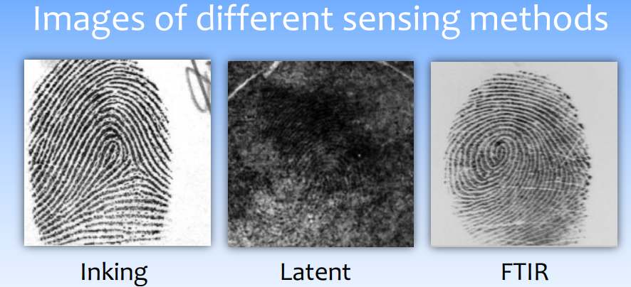
* Compared to inking and FTIR fingerprints, quality of latent fingerprint is much lower.
* Minutiae-Based Representation (level 2)
  + 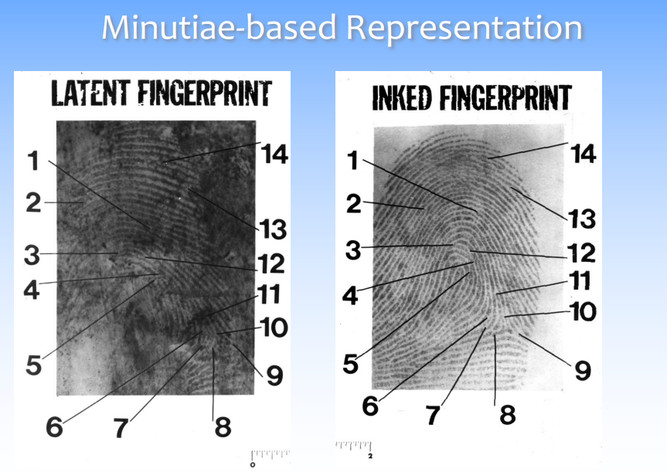
* Fingerprint Representation
  + Local ridge characteristics(minutiae): ridge ending and ridge bifurcation
  + Singular points: Discontinuities in ridge orientation
* Real World - FBI Example
  + Lights Out Mode: machine makes the final determination. No human examiner is involved.
  + Lights On Mode: A machine is used to receive a candidate list. Depending upon the procedure, a human examiner is used to make the final determination.

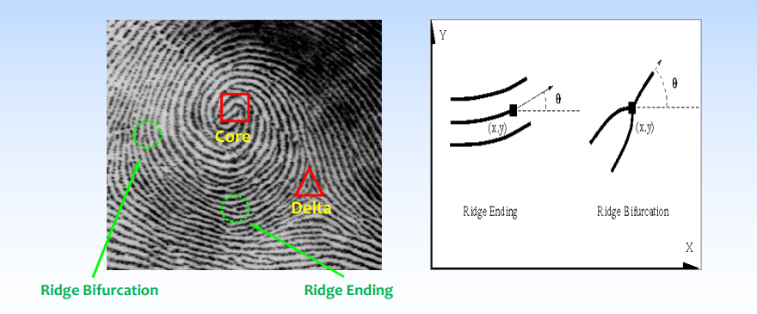

* Number of cores should be equal to the number of deltas.
* Minutiae point characterized by 3 values: x, y, and Θ.
* Minutiae Extraction: Input Image > Orientation Estimation > Ridge Filter > Ridge Thinning Minutiae Detection > Post Processing > Minutiae Extraction
* 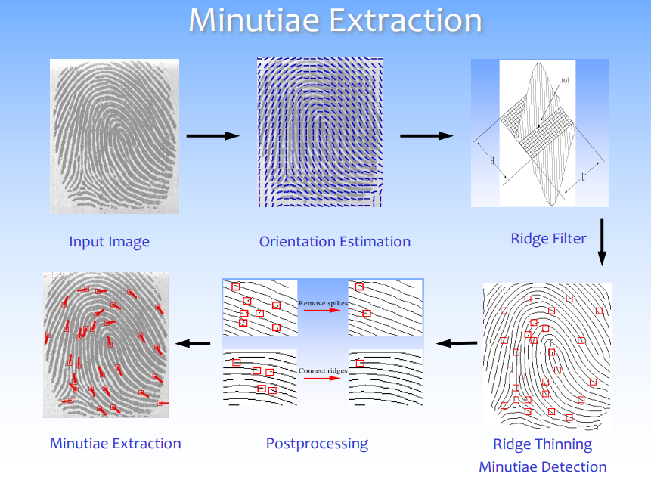
* View image as matrix. Binary matrix. Full of 0s and 1s. A 0 is a dot, a 1 is a bright pixel. If there is a 3x3 mask, and slide it over a matrix. If you check the middle of the matrix as you move the mask, if the middle is a zero,
  + Ridge ending: 2
  + Ridge Bifurcation: 3
* 3 Factors affecting fingerprint recognition
  + Pressure
  + Non-uniform deformation
  + Rotation and translation
* Intra-class Variation
  + Lead to high False Non-Match
* RANSAC (Random Sample Consensus)
  + Match minutiae points of two fingerprint scans
* 